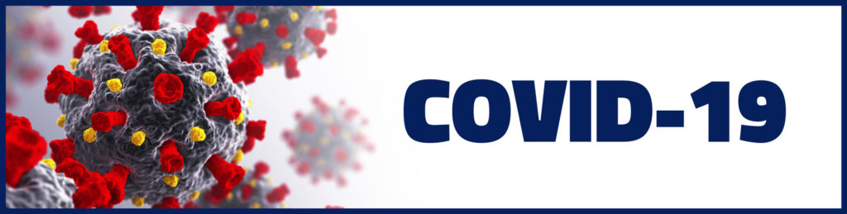

Illinois Department of Public Health
2021 Illinois Governor’s COVID-19 Hometown Hero’s Award Nomination Application
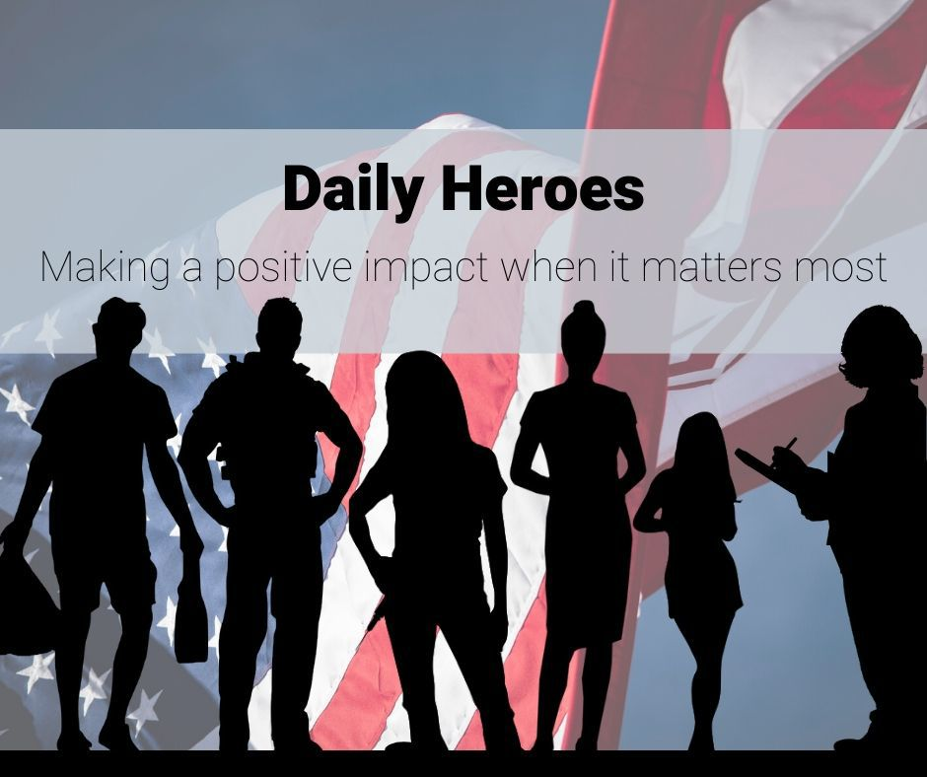

About the Award
The State of Illinois has learned during the pandemic that heroes come in all shapes and sizes. What they have in common is making a difference in the lives of other people during an unprecedented time of change and struggle. We often think of first responders and essential workers when we are celebrating the heroes of COVID-19, but everyone in the Illinois community has stepped up in extraordinary ways and any good deed is worth celebrating. So whether it’s an individual, employee of an company, community group, neighbor, or friend, shine a light on your COVID-19 heroes by nominating them for the ways their efforts have improved the wellbeing of others, used their agility to redesign a process, or whose spirit of service inspired others.
During the Illinois State Fair, the COVID-19 Illinois Governor’s Hometown Hero’s Award Program will provide an opportunity to recognize those who provided outstanding service in the course of the pandemic. This could be service performed for their local neighborhood, community, town, village, township, county and city and beyond by exemplifying the All-in-Illinois Experience. Those who have taken on extra duties to help the State of Illinois through the COVID-19 pandemic are also eligible for the award, but those extra duties must have been sustained or extraordinary.
Selection Criteria:
Recipients of this award should have:
- Provided outstanding service and achievements during the COVID-19 pandemic to the State of Illinois communities and beyond
- Had sustained or extraordinary additional duties due to the pandemic
- Demonstrated the All-in-Illinois Principle
Service Dates:
May 1, 2020 - June 30, 2021
Application Due: July 25, 2021
Please note: This form can be edited and returned to until July 25, 2021 at 11:30 p.m.

TYPE OF APPLICANT
Is this an individual or group? *
Individual
Group
Name of Project? *
Project Category *
Illinois General Assembly members Illinois General Assembly members that represent the applicant’s district:

district
Representative *
Senator *
(Legislative information is requested only for purposes of inviting legislators to the Awards. To find the legislators, go to: www.elections.il.gov/)

Nominee Details
Title *
Mr.
Mrs.
Miss
Ms.
Name *
Address *
County *
Phone Number *
Email Address *
Date of Birth or Age *
Gender *
Male
Female
Unidenitfied
Nationality *
Ethnicity *
Length of service *
Please detail your nominee’s service and achievements in 350 words or less during the COVID-19 response *
Please tell us how your nominee/group normally gives their time outside of the COVID-19 response - Please detail the nominee’s other posts or roles in 200 words of less. For example, volunteer, fundraiser, school governor *
Please provide any additional information you feel is relevant. This could include but is not limited to evidence of their work, letters of support and newspaper articles. *
Please upload any supporting evidence

Nominators Information
Title *
Mr.
Mrs.
Miss
Ms.
Name *
Address *
County *
Phone Number *
Email Address *
Gender *
Male
Female
Unidentified
Ethnicity *
Your Relationship to nominee *
THANK YOU FOR APPLYING TO THE
2021 Illinois Governor’s COVID-19
Hometown Hero’s Award!
Applications can be edited until July 25, 2021 11:30 p.m.
If you cannot upload documents, information can be mailed to the contact postmarked by the deadline.
If you have questions, please contact:
Yolanda Jones, Hometown Heroes Coordinator
Illinois Department of Public Health
535 West Jefferson
Springfield, Illinois 62761
217-785-4894

Powered by

